# **Hydrogen production at low potential**

1. **The hydrogen economy**
2. **Hydrogen production methods**
3. **Pourbaix diagram of water**
4. **Experimental setup**
5. **Conclusion**

**The hydrogen economy**

The hydrogen economy is an umbrella term which envisions the role of hydrogen as a possible fuel to replace fossil fuels in energy generation and thus minimizing the effects of greenhouse gas emissions. The calorific value of hydrogen is 150000 KJ/Kg which is the highest calorific value of any fuel. Hydrogen is also the most abundant element in universe, it also boasts an incredible advantage as a zero-emission fuel. When hydrogen undergoes combustion or operates in fuel cells, the sole by-product is water vapour, a testament to its environmental cleanliness. These properties further amplify its chances as a possible reliable fuel soon.

**Hydrogen production methods**

There are three widely used hydrogen production methods. Based on the method used, hydrogen produced is classified as grey hydrogen/ blue hydrogen/ green hydrogen.

**Grey hydrogen:** Grey hydrogen is primarily produced through a process called steam methane reforming (SMR).

**Chemical reaction: CH4 +H2O = 3H2+CO2**

Grey hydrogen is considered least environmentally friendly, as it releases substantial carbon dioxide into the atmosphere, leading to greenhouse gas emissions.

**Blue hydrogen:** Blue hydrogen utilises the same SMR technology but includes Carbon capture and storage (CCS) technology. This significantly reduces carbon emissions. It is considered as a transitional step towards cleaner hydrogen production.

**Green hydrogen:** Green hydrogen is the most environmentally friendly option. It is produced using renewable energy sources, such as wind or solar power, to perform water electrolysis.

**Chemical reaction: 2H2O + energy (from renewable sources) = 2H2 + O2**

Green hydrogen is entirely clean, producing zero carbon emissions during production. It represents the future of sustainable hydrogen production.

**Pourbaix diagram of water:**

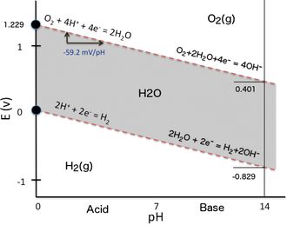During electrolysis of water, energy(electricity) is required to breakdown water into hydrogen and oxygen. Thus, if we can minimise the potential at which hydrogen is produced or if we can increase the current at constant external potential, one of the main constraints of green hydrogen production will be solved.

From the Pourbaix diagram of water, it is observed that if oxygen is produced at pH=14 and hydrogen is produced at pH=0, then effective difference in potential of the two reactions is 0.4V, which is the ideal potential for H2 production.

**Experimental setup:**

Preparation of an acid-base couple bath.

Acid- HCl

Base- KOH

Electrolyte- Tap water

In our experiment, we keep the external potential constant at 5V and then vary other properties such as distance, addition of acid/base to study the effects of these changes on output current and then we arrive at a suitable condition for green hydrogen production.

1. **When distance between electrodes is decreased**

The above graph shows variation of current with time as the distance between the electrodes is increased keeping the potential constant.

Observation- As the distance between the electrodes is increased, current abruptly drops down to zero and then stabilises to a lower value with progress of time. This shows that any abrupt change in the distance between electrodes will lead to sharp increase in resistance offered so the current will decrease exponentially. As time is provided for the setup to stabilise, current reaches a certain value which is lower than the original value. The main point to observe is that with a linear increase in distance, current decreases non-linearly.

1. **When Acid is added to H2 and Base is added to O2**

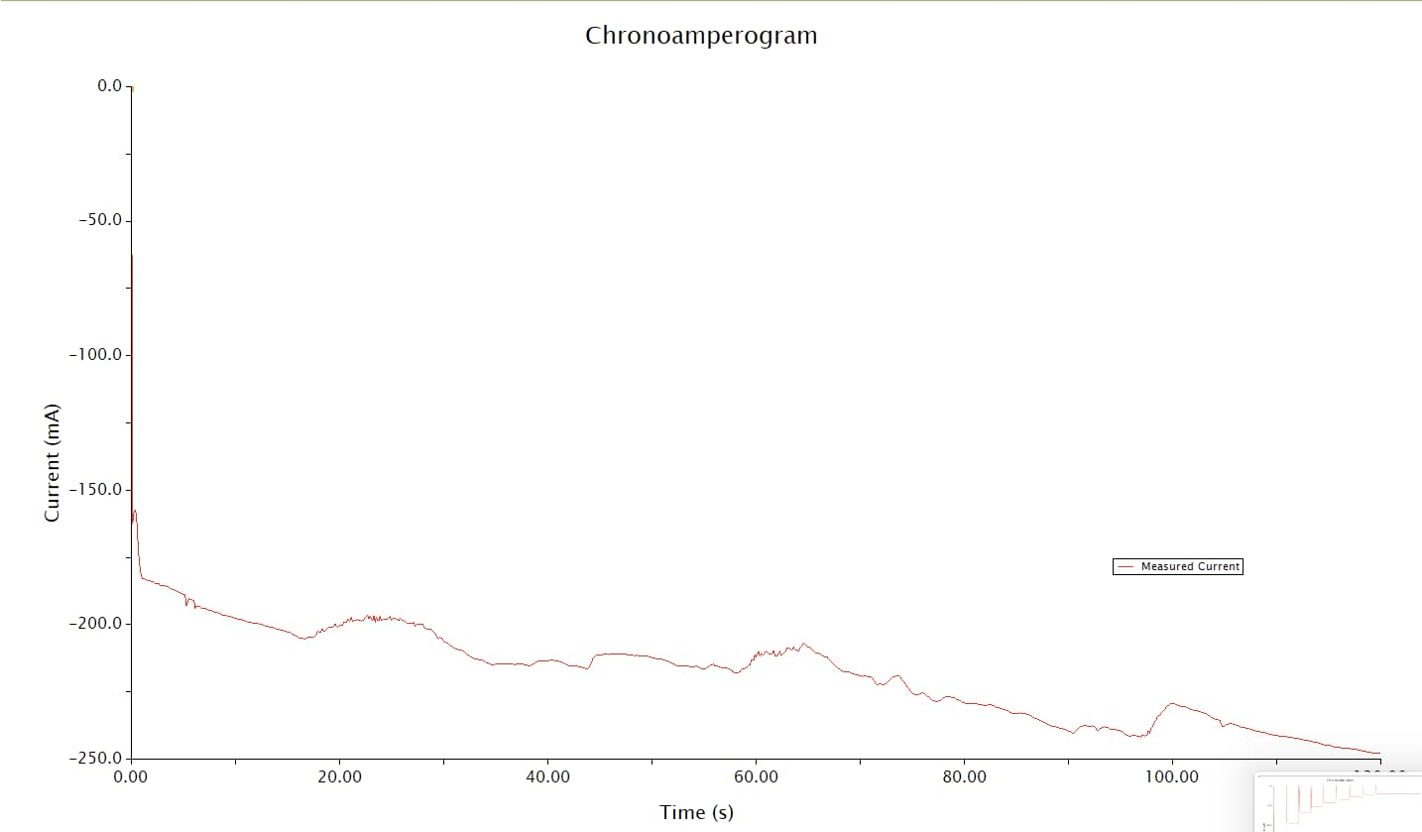

Initially, as the contents of the system are consumed due to production of H2 and O2 , current will decrease with time. Now we add Acid to H2 producing site and base to O2 producing site, by Le-Chatelier’s principle, addition of acid to H2 will increase the overall content of H+ ions in the system, so the system will try to nullify this effect by producing more H2 and hence it becomes easier to produce H2 when acid is added to H2 producing site/electrode. Therefore, we see slight increase in current when we add acid to H2 and base to O2, as time is provided for the system to stabilise, current again drops due to consumption of acid and base which leads to formation of H2 and O2 and continues in the same way until the point where we again add acid to H2 and base to O2 when once again, we observe increase in current in the graph above.

**Conclusion-** Thus we observe that by varying the parameters of the system like distance between the electrodes, addition of acid/base, we can optimise the conditions for green hydrogen production.